UPPWISE INDIA

www.uppwise.com

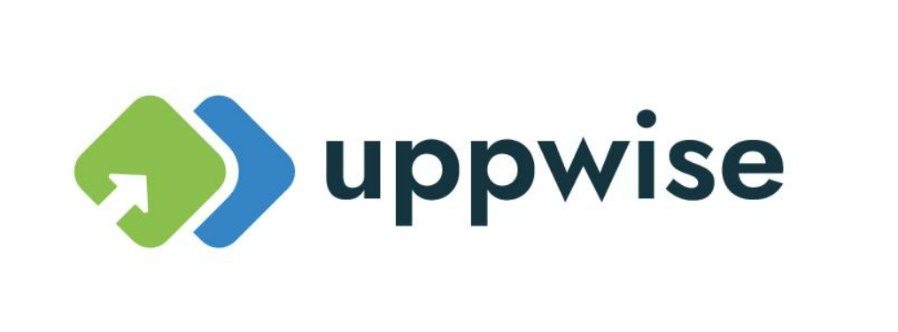

**Quaterly Development Planning**

**Q1-2024**

**Feature: Visibility permission for custom and standard fields label**

**Feature Title:**

Visibility permission for custom and standard fields label

**Priority:**

Medium

**Submitted By:**

SPM

**Target Users:**

Standard – Customer: AXA

**Feature Description:**

To address visibility permissions for both custom and standard field labels, a development initiative will be undertaken within the Role Management section of the cost and benefits management feature. This initiative will introduce an icon to facilitate configuration extension, triggering a popup window containing customizable fields.

**Acceptance Criteria:**

**Icon Integration:** Within the Role Management interface, an icon will be incorporated to initiate configuration extension, providing users with access to advanced visibility settings.

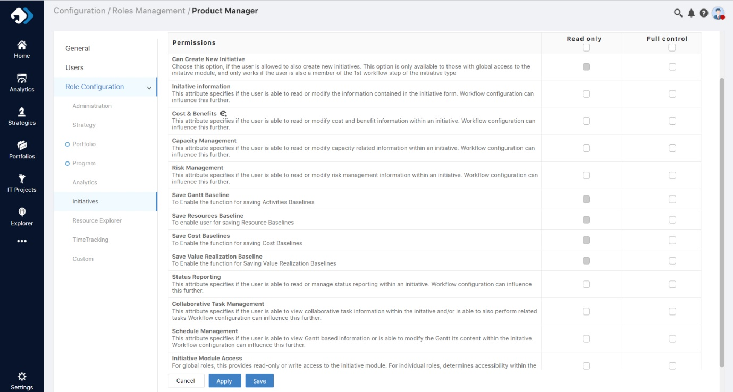

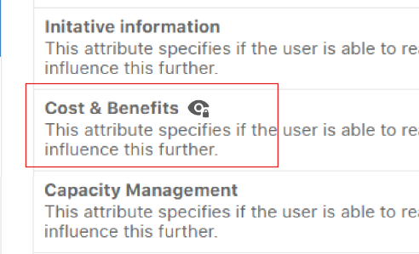

**Popup Configuration:** Clicking the icon will prompt a popup window to appear, housing both custom and standard fields. This interface will enable users to selectively define visibility permissions for each field based on their assigned roles.

**Permission Definition:** Users with appropriate roles will have the ability to specify which fields should be hidden or visible to users within their role. This feature allows for granular control over field visibility, enhancing customization options.

**Default Visibility:** Upon opening the popup window, all fields will be initially visible by default. This ensures a seamless user experience and provides users with immediate access to all available fields.

